# **Why we use EC2?**

You can use Amazon EC2 to **launch** as many or as **few virtual servers** as you need, **configure security and networking, and manage storage.** Amazon EC2 enables you to scale up or down to handle changes in requirements or spikes in popularity, reducing your need to forecast traffic.

Configure Own Server means its a wizard and launch instance and create

1. Choose a AMI
2. Choosing an Instance type
3. Configure Instances:-We have to specify number of instances, purchasing options, the kind of networks, the subnet, when to assign public IP, the IAM role and Shutdown behaviour
4. Adding Storages
5. Add tags
6. Configure security tools
7. Review

**Steps to Launch EC2 instance**

1. Login with user account which is created by the user and has permissions given to access EC2 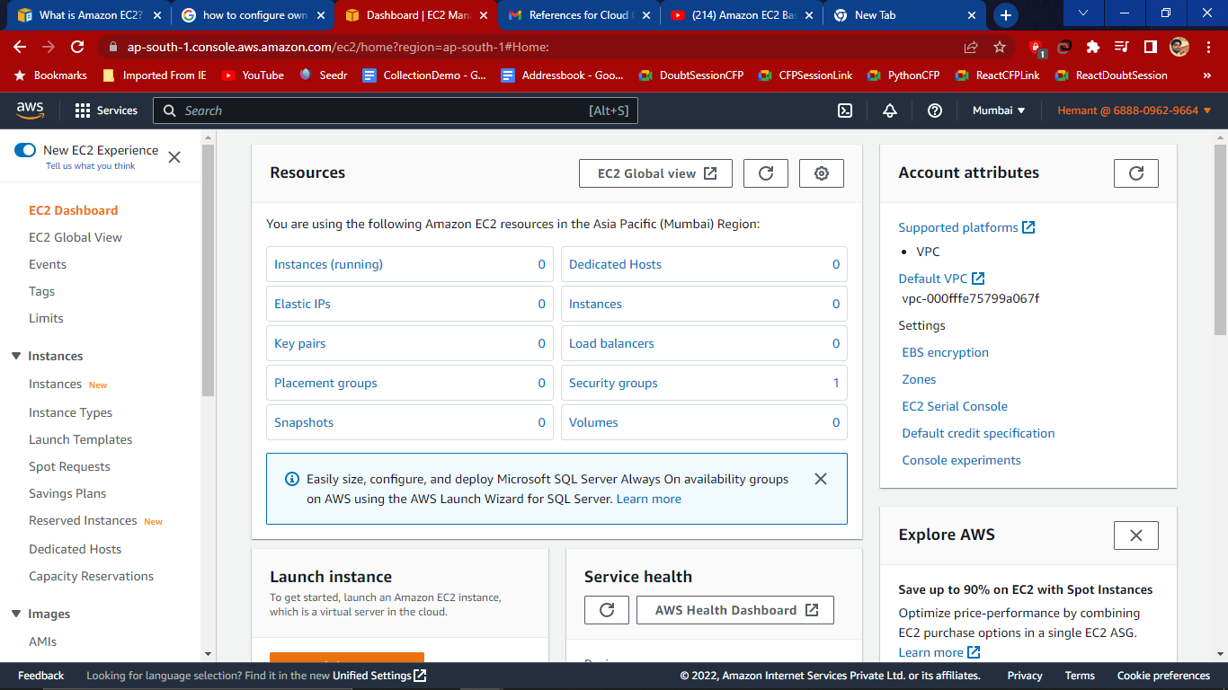
2. Then click on Launch Instances to get started Amazon EC2 Instance which is a virtual server in the cloud. And then in dropdown click on launch Instance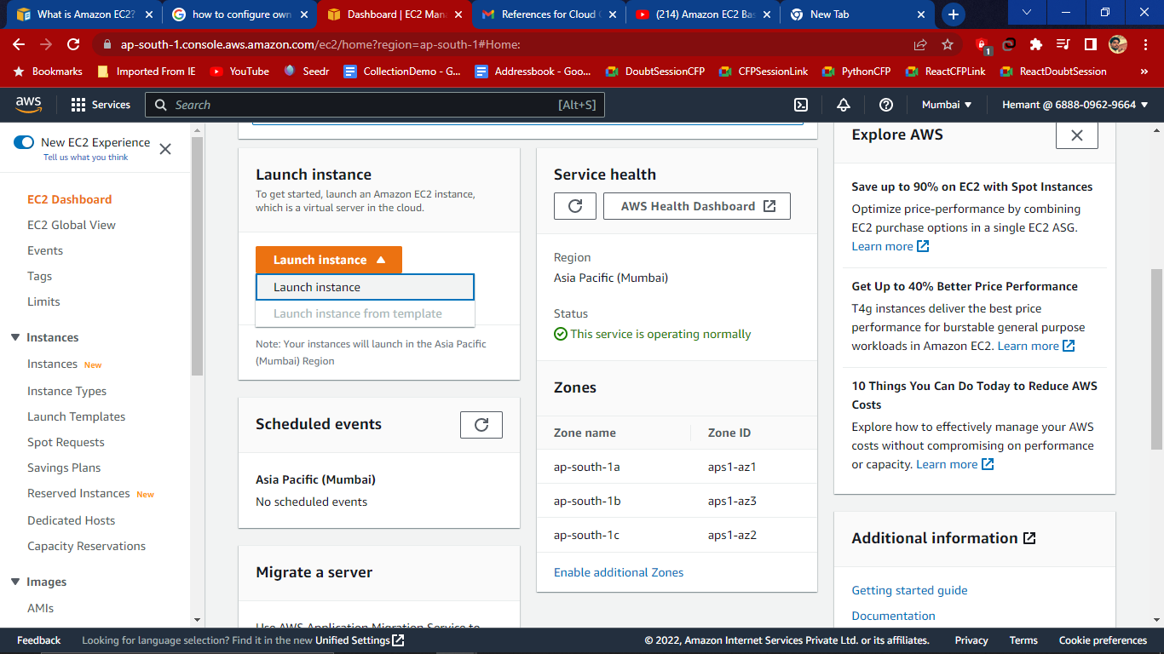
3. In the Launch an Instance now give Name and Tags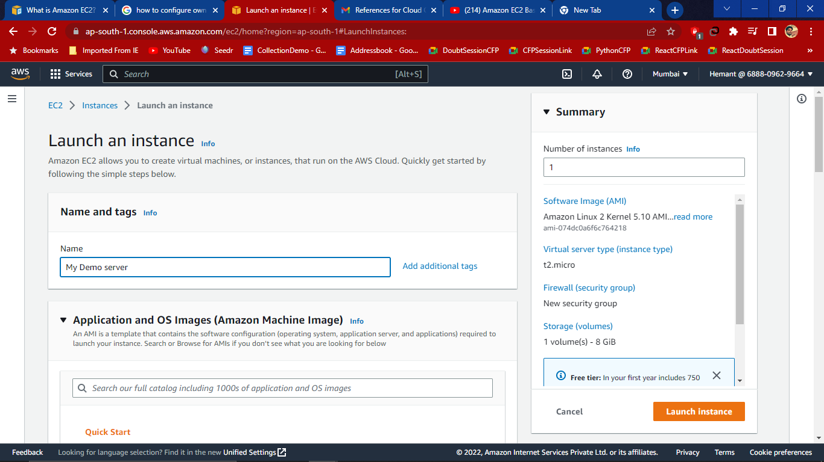
4. Application and OS image (Amazon Machine Image)

An AMI is a template that contains the software configuration (operating system, application server, and applications) required to launch your instance. Search or Browse for AMIs if you don’t see what you are looking for below.

Now choose AMI from the list for now I’ll configure with Windows server and after selecting it will get Description and Architecture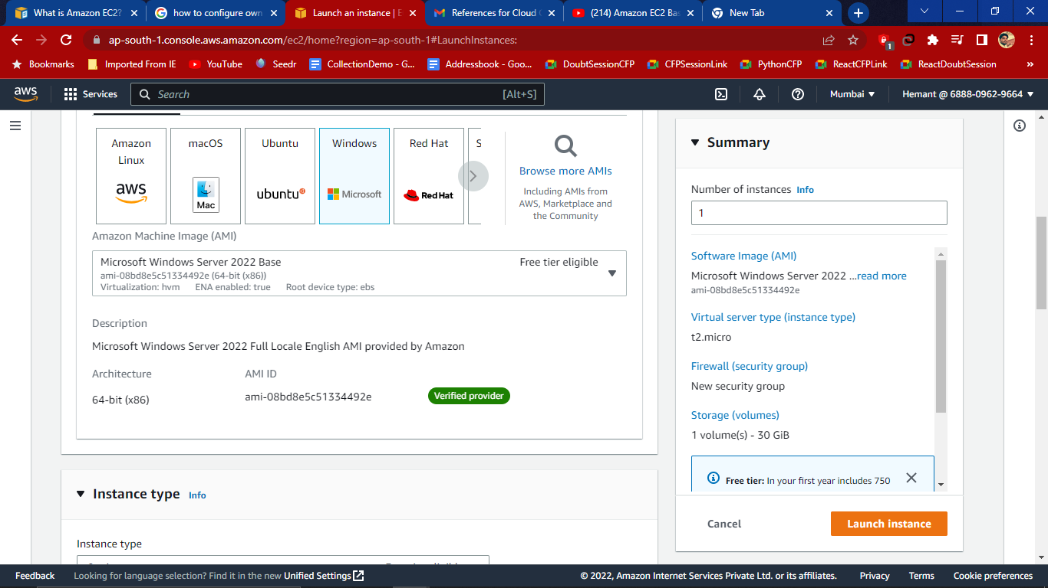

1. Select Instance type as t2.micro which is free tier eligible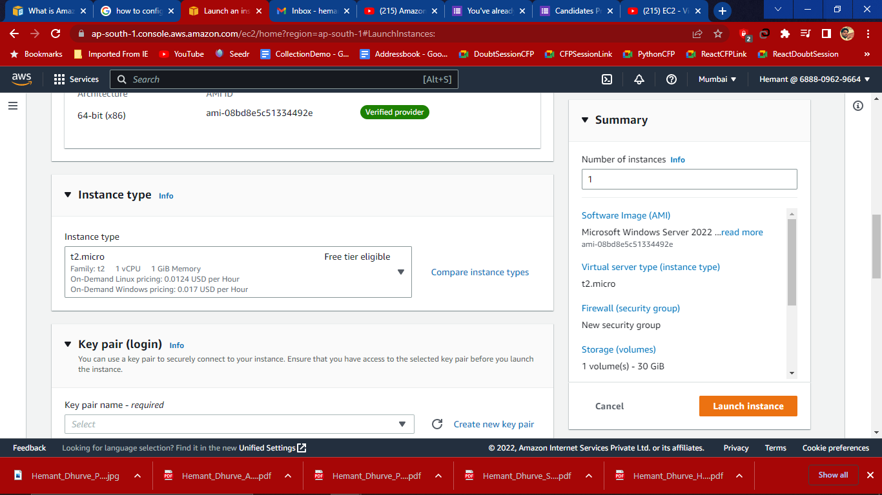
2. Key Pair (Login)

Create key pair and download .pem file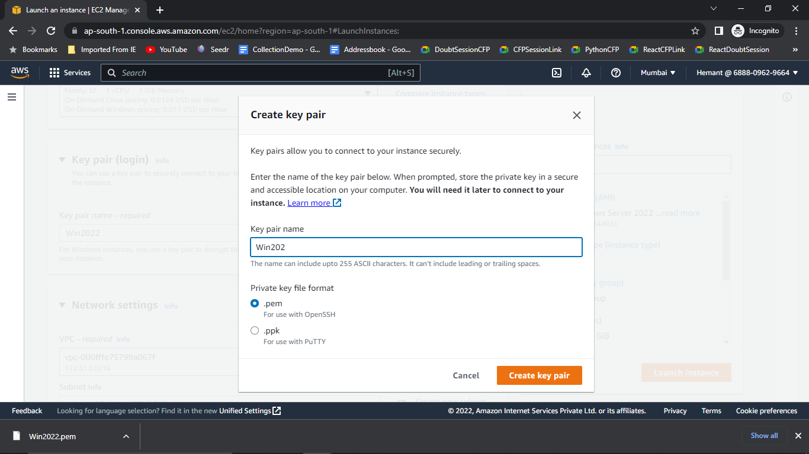

1. Network Setting

Choose VPC -default

Subnet- choose Availability zone ap-south-1a

Auto-assign public IP- Enable

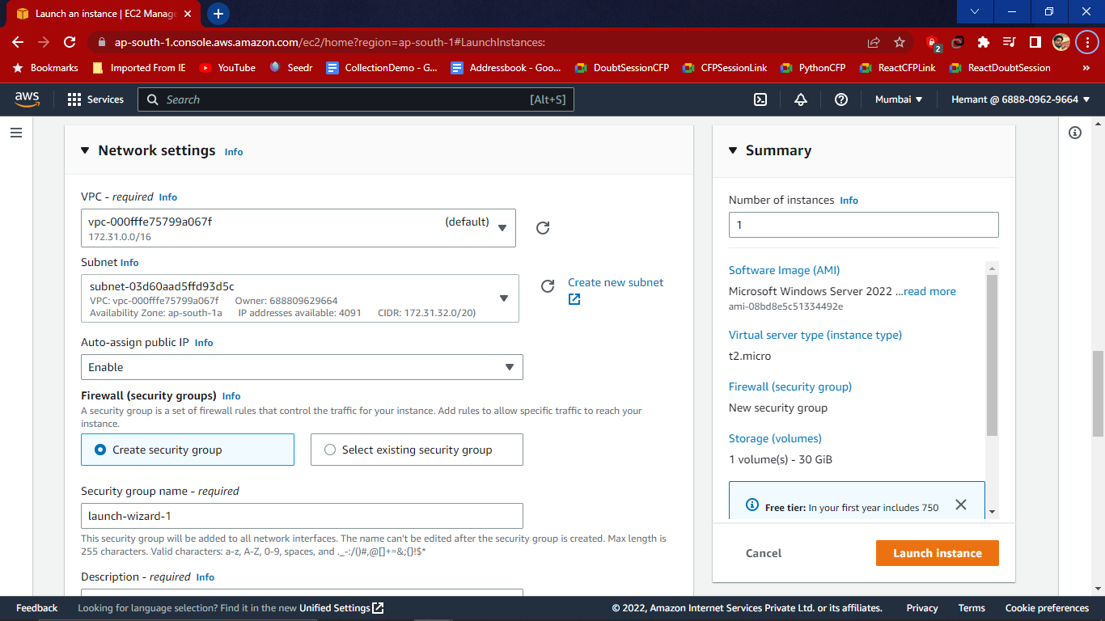

1. Configure Security group (firewall )

First create Security group then give name to the security group and description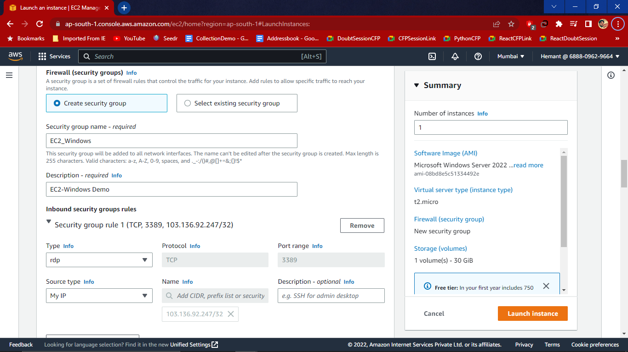

1. Inbound Security Group Rule-

Select Type-RDP

Source Type- Anywhere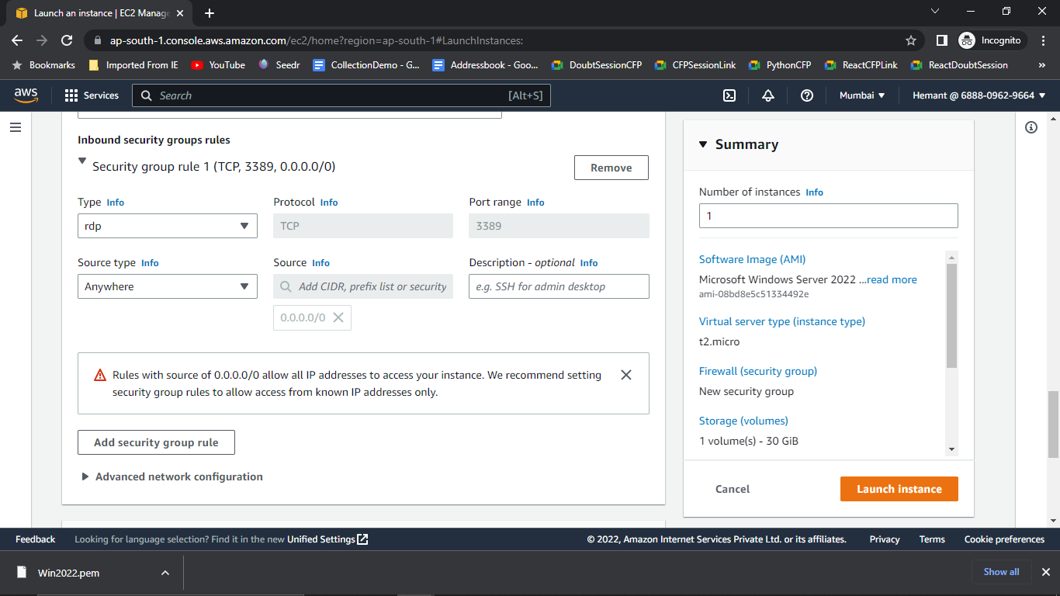

1. Create a key pair and then in Network setting create a security group with 2 types i.e SSH and HTTP or HTTPS. These are used to make a html page in the webConfigure storage- 30gb which is for the free tier customers of ESB General Purpose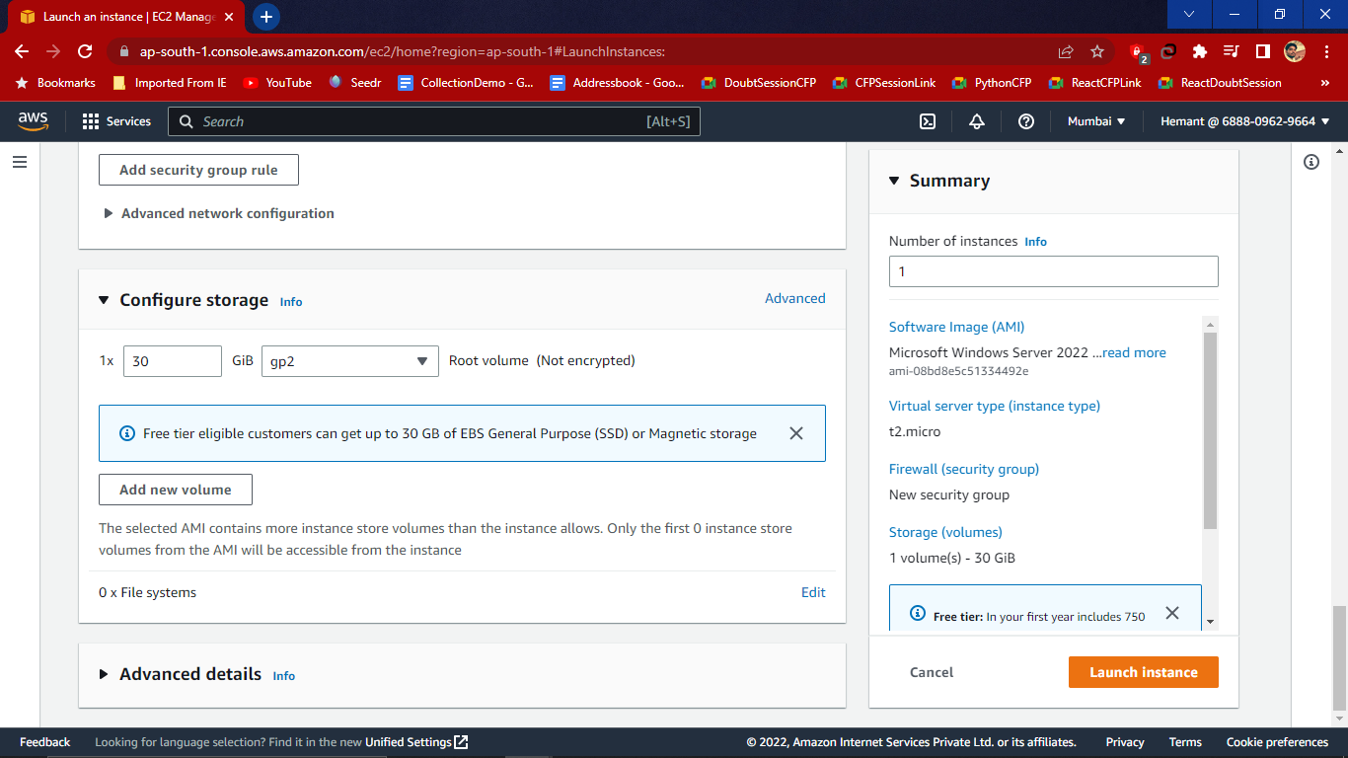
2. Click on Launch Instance before that to check all the summary. Here Instance is created.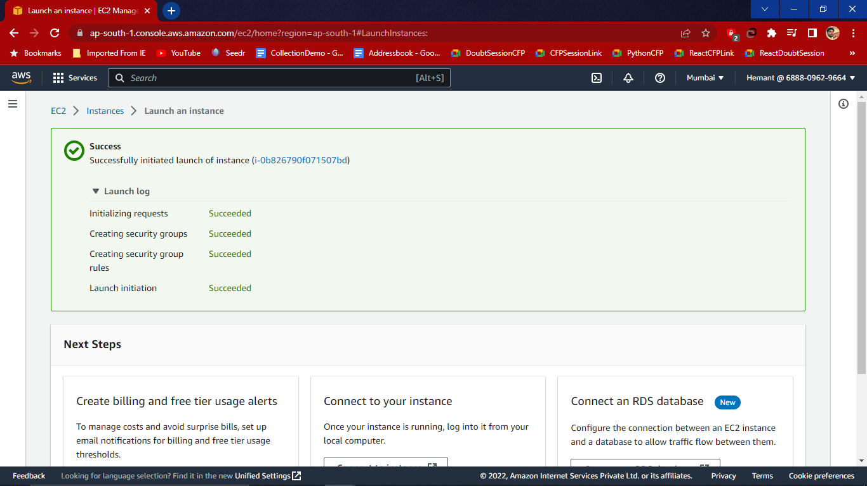

Now we able to see the instance in dashboard with all the details.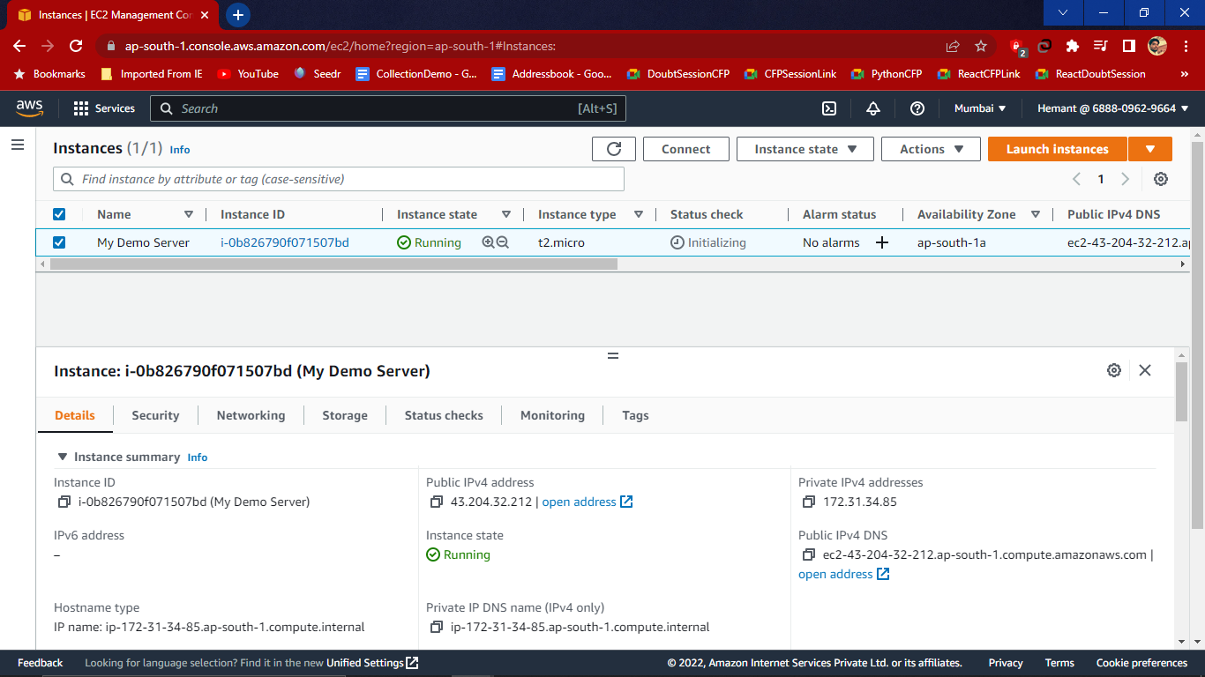

Here Instance State is Running means Instance is running and now we have to wait up till status check is on green.

1. Now to retrieve the default administrator password- click on **Actions** and then Under **Security** Get **Windows Password**.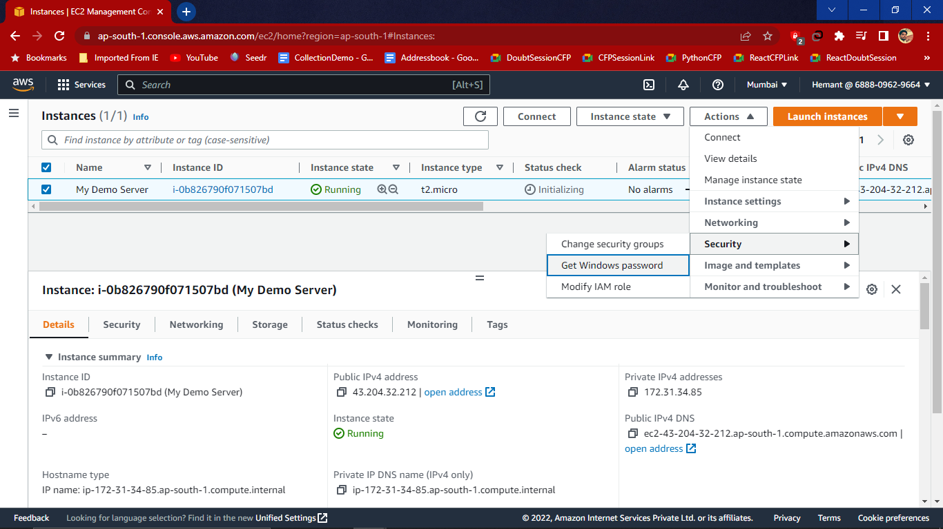
2. Now run the RDP- Remote Desktop Connection (manually by searching in the windows) and RDP popup opened then provide public DNS and then click on RDP client and upload .pem file

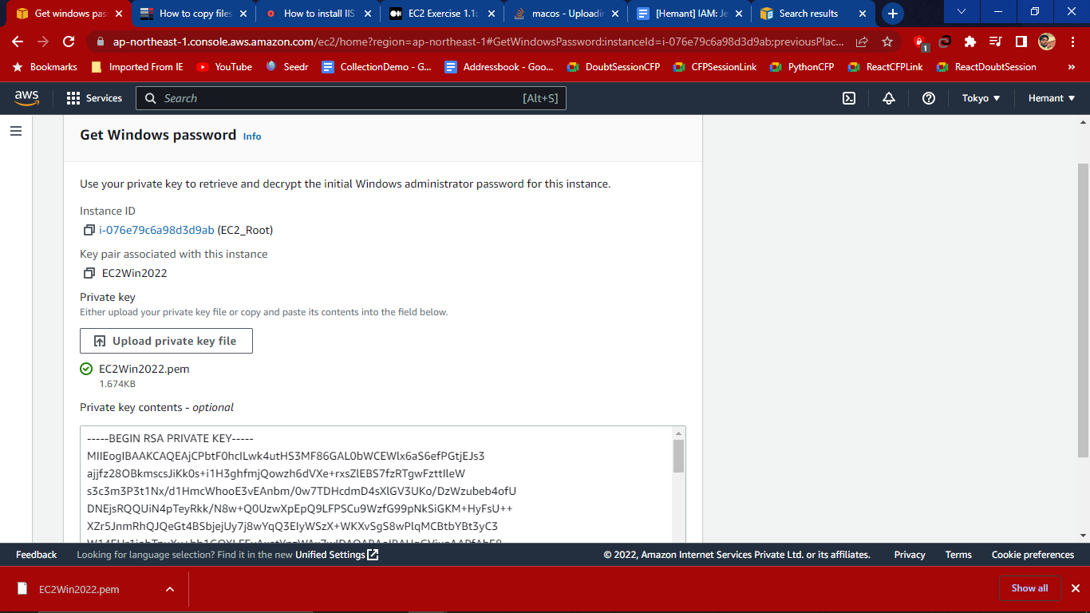

1. Then click on decrypt password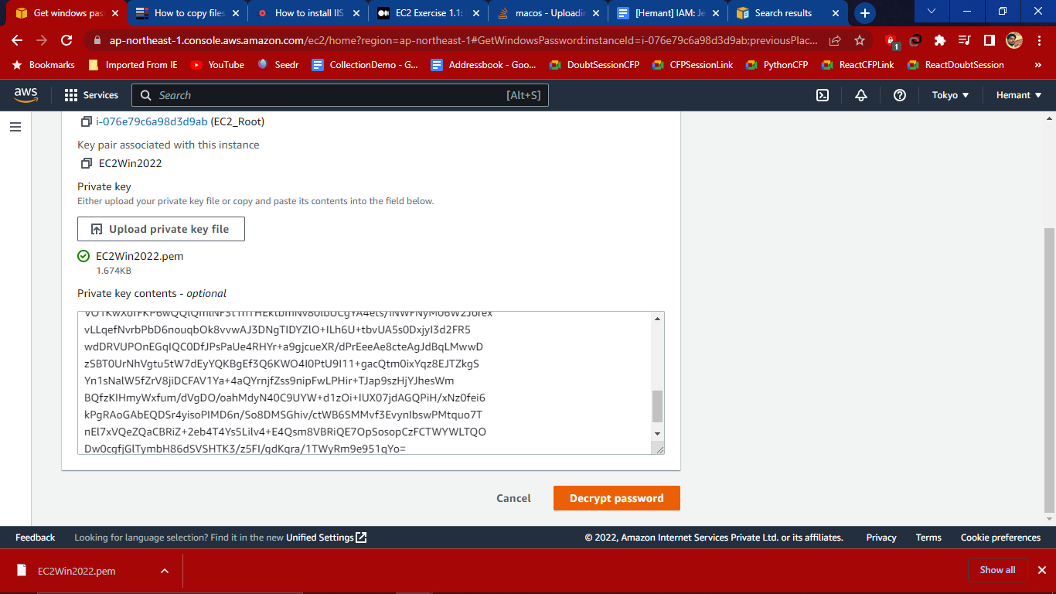

Then we have get the generated password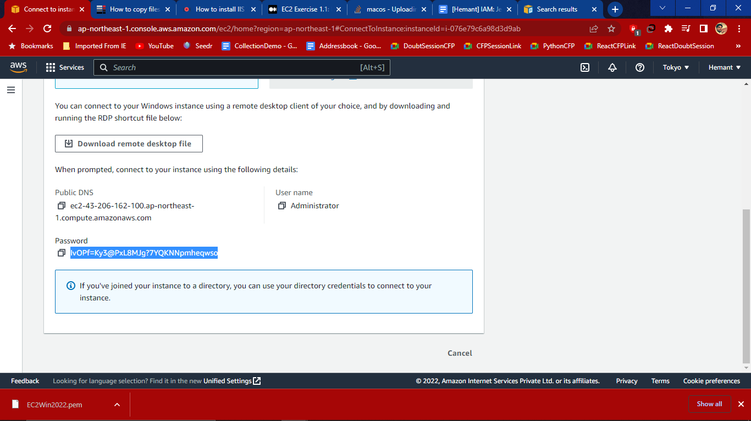

Then paste this generated password in the RDP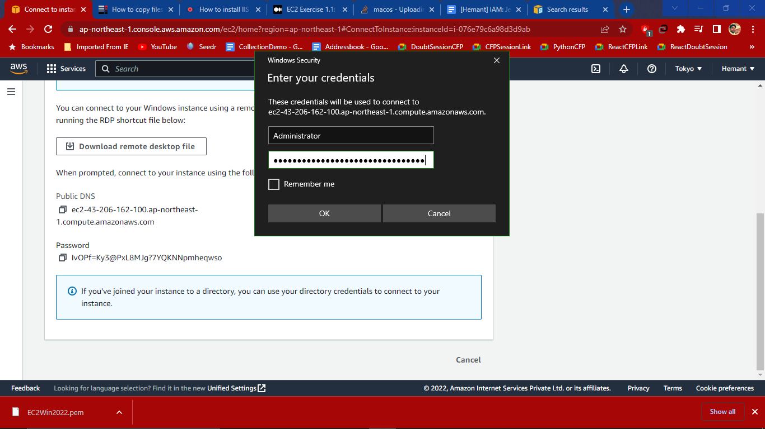

1. 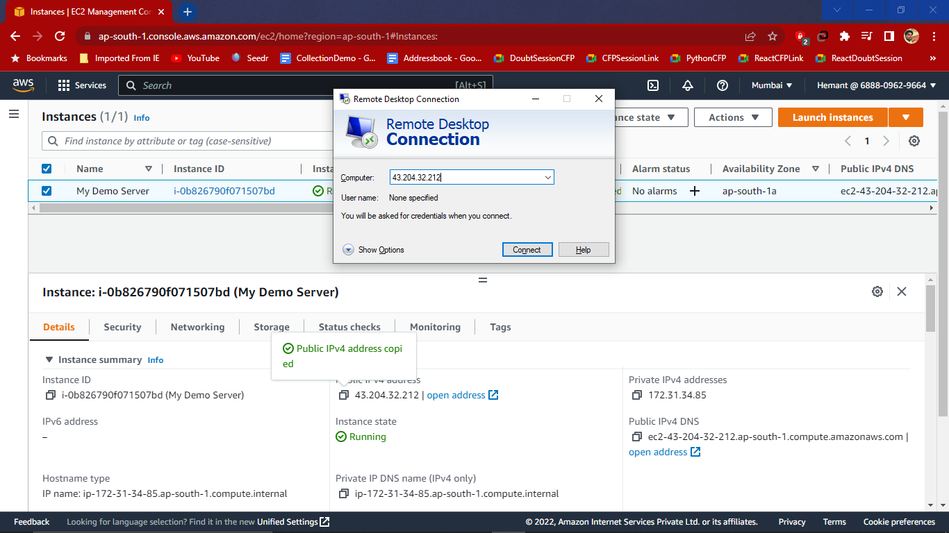

Then click on Connect

# Upload file from local to live server?

1. First download WinSCP from the official site and install it
2. WinSCP dashboard is now open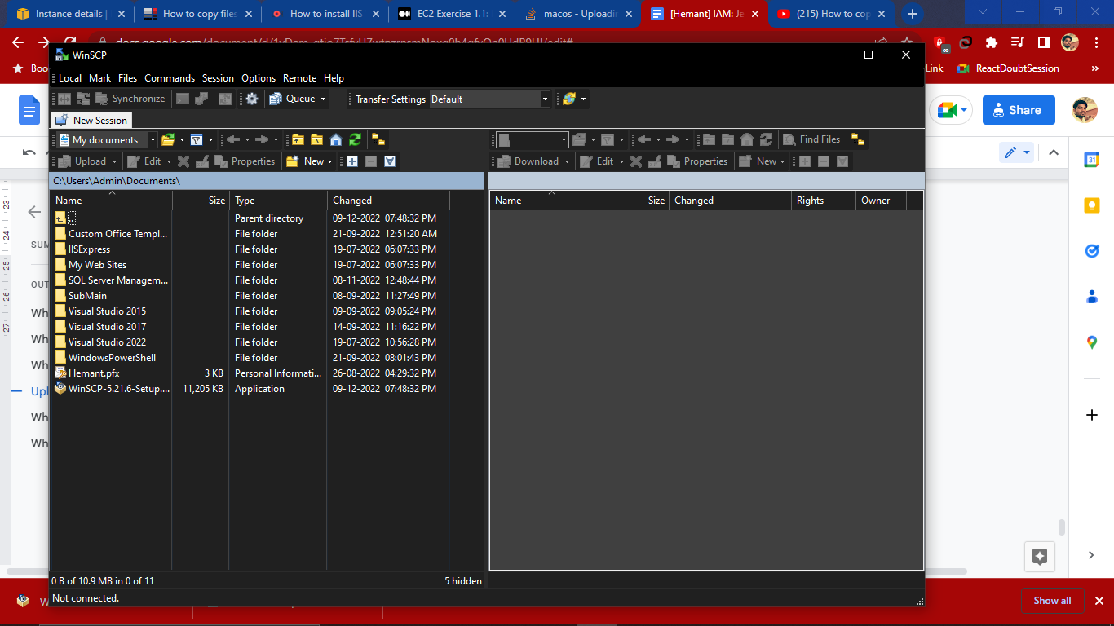
3. Then create New session and Paste the public IP address in the Host and the click on Advanced to get the password and userName will be our Administrator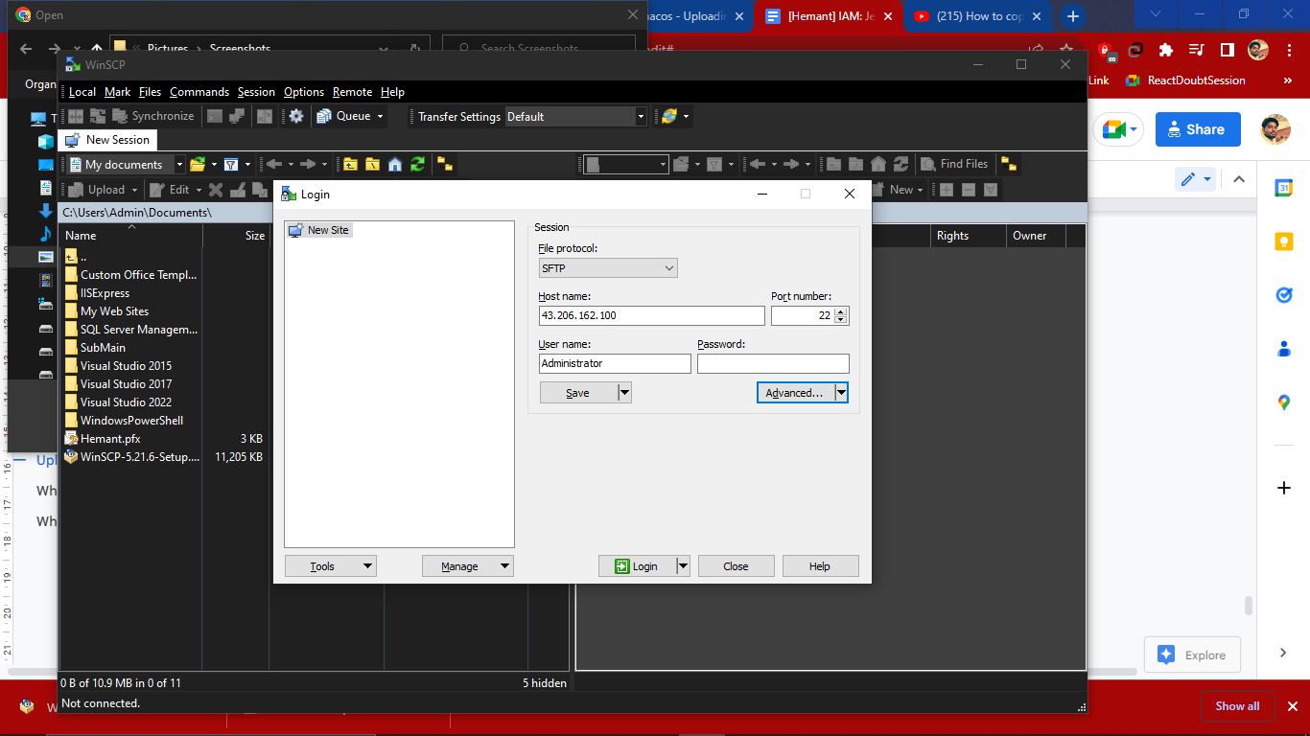
4. Under Advance -SSH-Authentication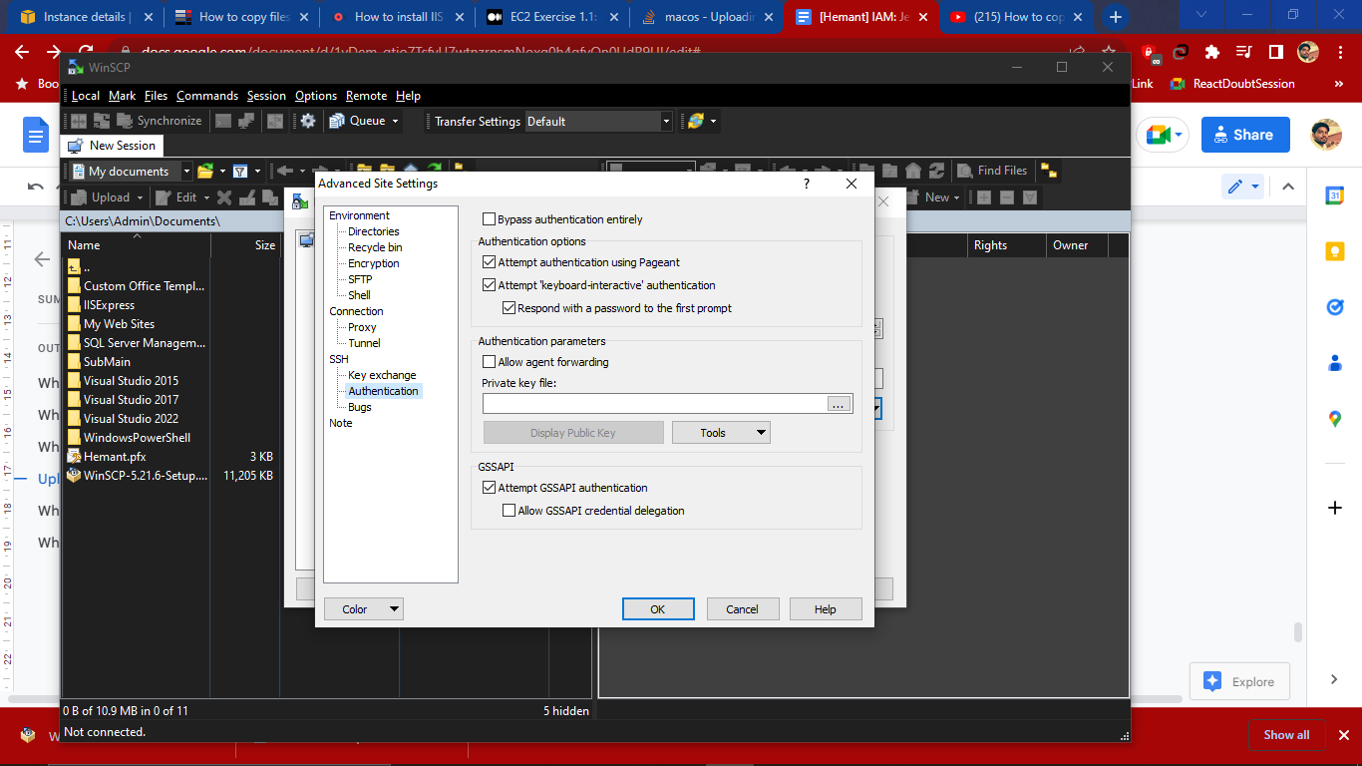
5. Then click on private key and browse for the .ppk file if the file is not present then convert it from .pem file to .ppk file which will automatically convert and save the path and then click on ok.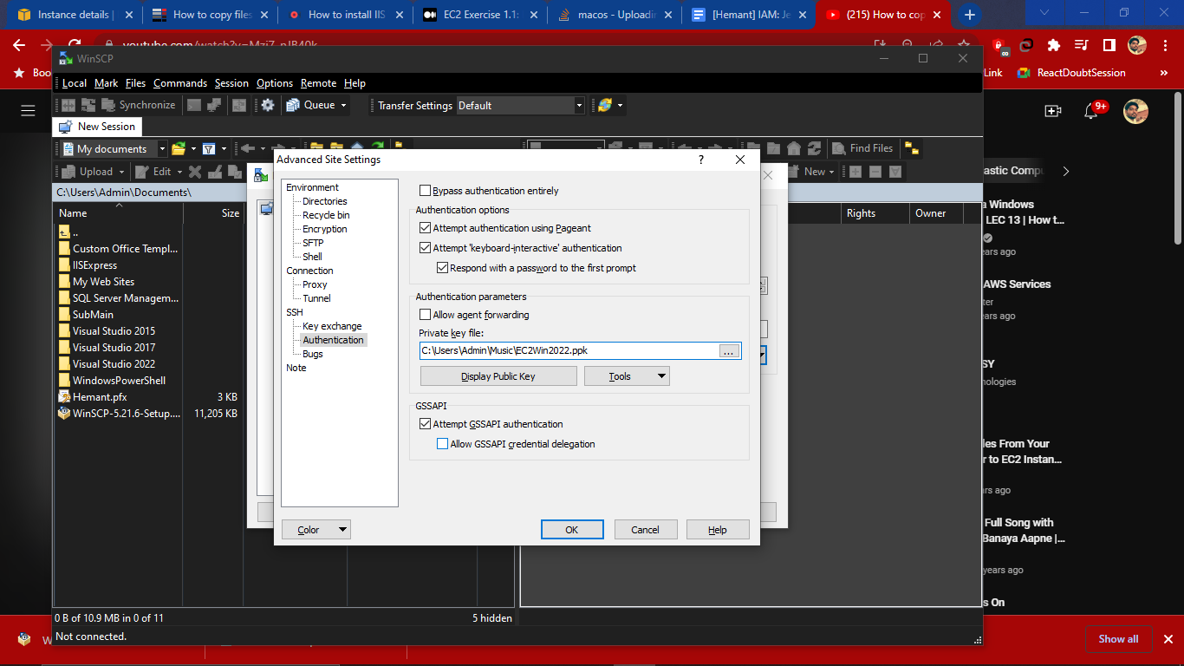
6. If you want to save the session then click on save and 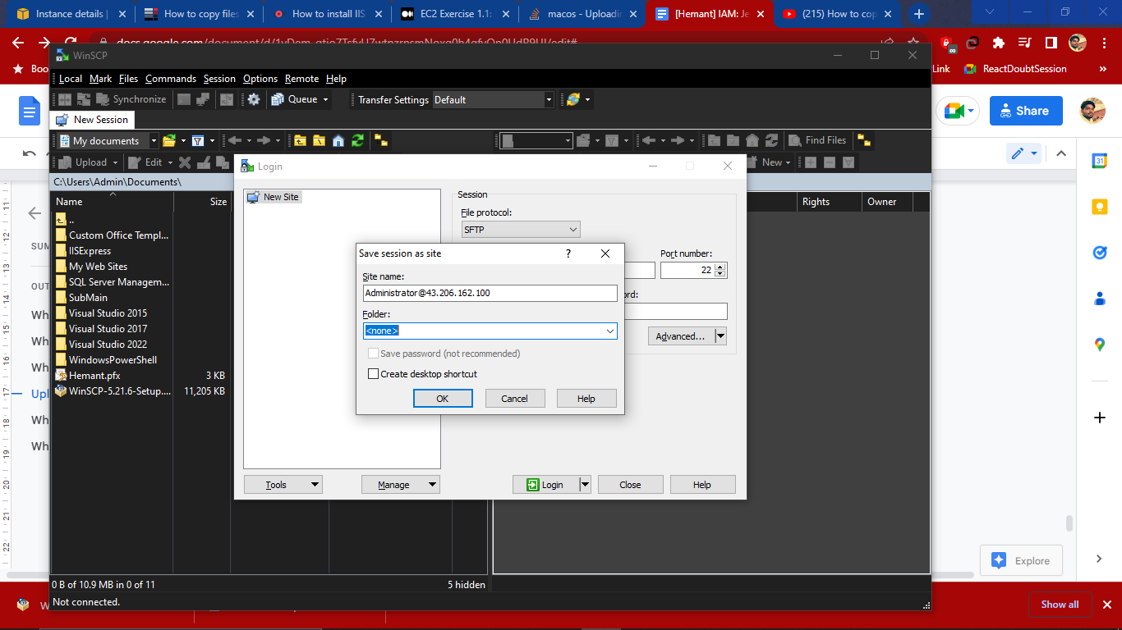

Then click on login

# What is Putty?

Putty is generally used when there is a windows system to connect with a linux system. Putty does not accept .pem file so to convert .pem file to .ppk file we use putty application

# What is Putty gen software?

Putty gen is a tool that helps to convert .pem file to .ppk file

So using the putty Key Generator, you create a new .ppk file with the Conversion> Insert key and load the .pem file .Then give the private key and find a location to save a key.

Now open the Putty configuration tool, provide your IP address and click on Auth then Browse and find the .ppk file

# **Make a static html page live on EC2 instance?**

1. Create new EC2 instance of linux server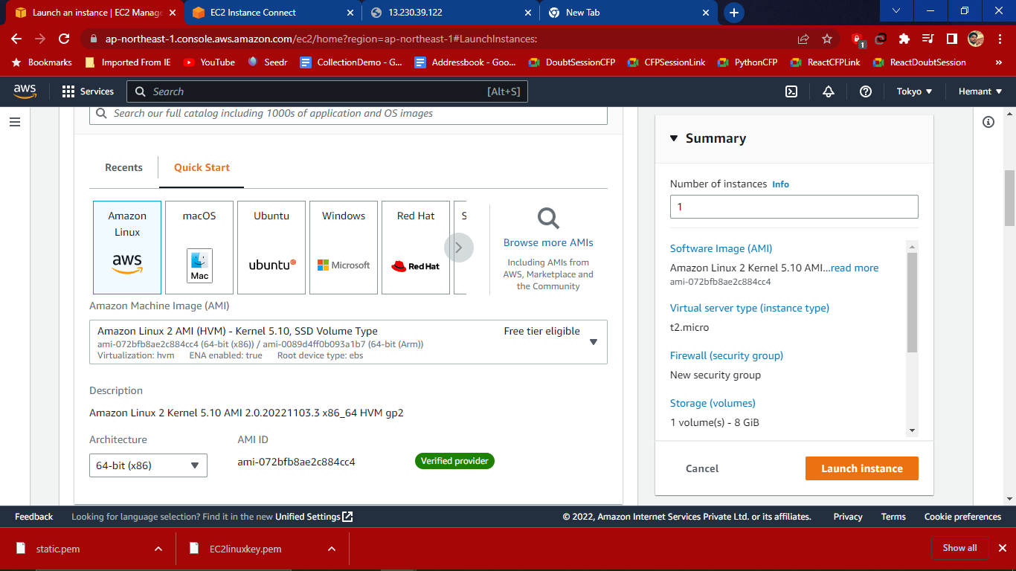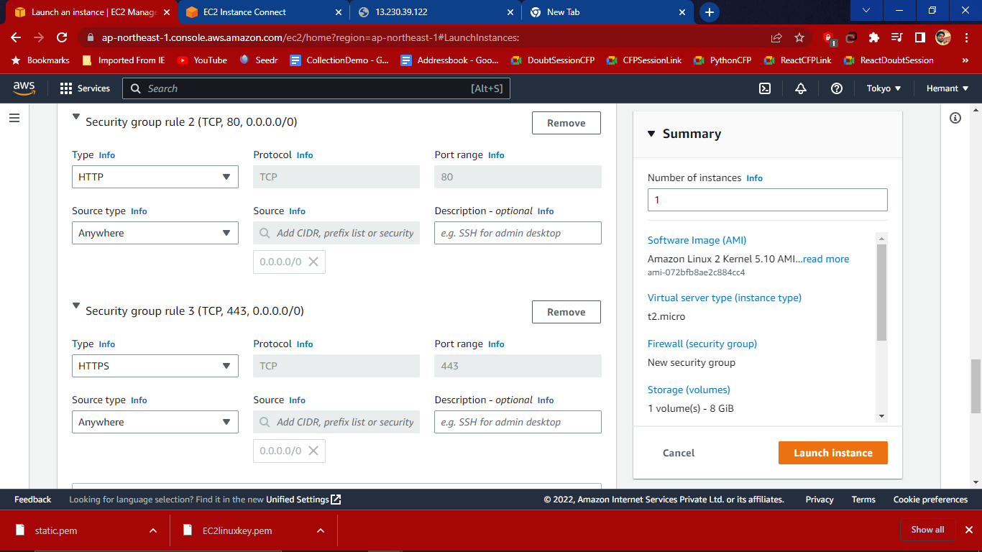
2. In configure storage leave as it is with 8gb and root volume gp2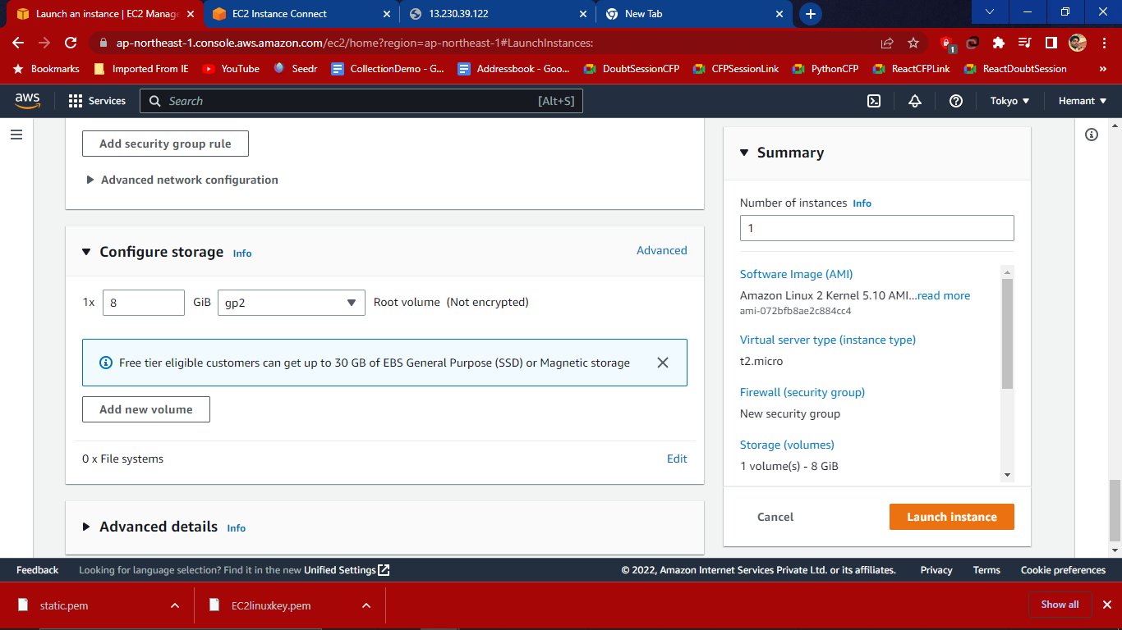
3. Click on Launch Instance to create an instance and after creating it shown up in dashboard.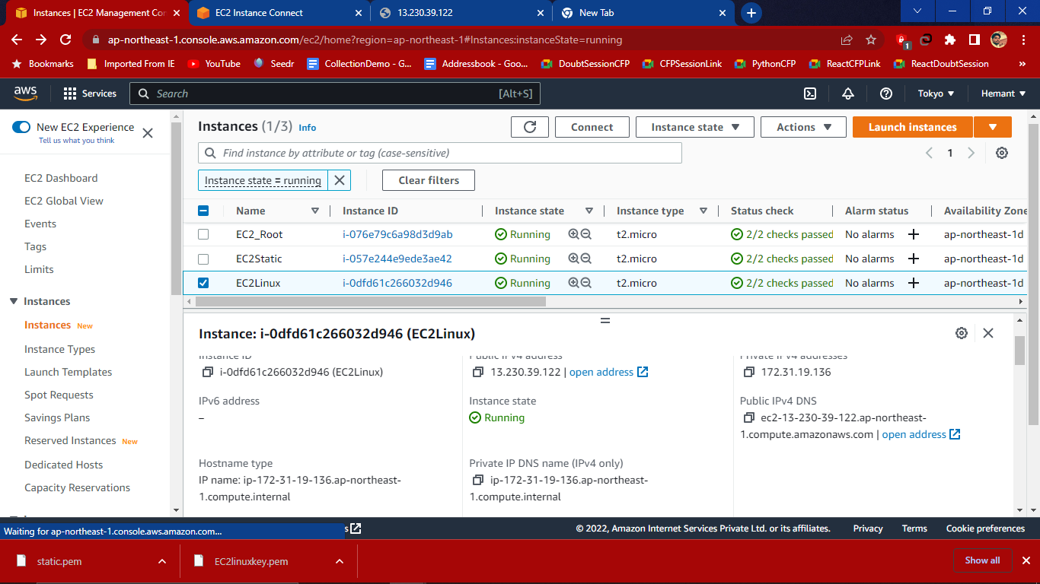
4. Then click on Connect and In EC2 instance connect give user name as ec2-user then connect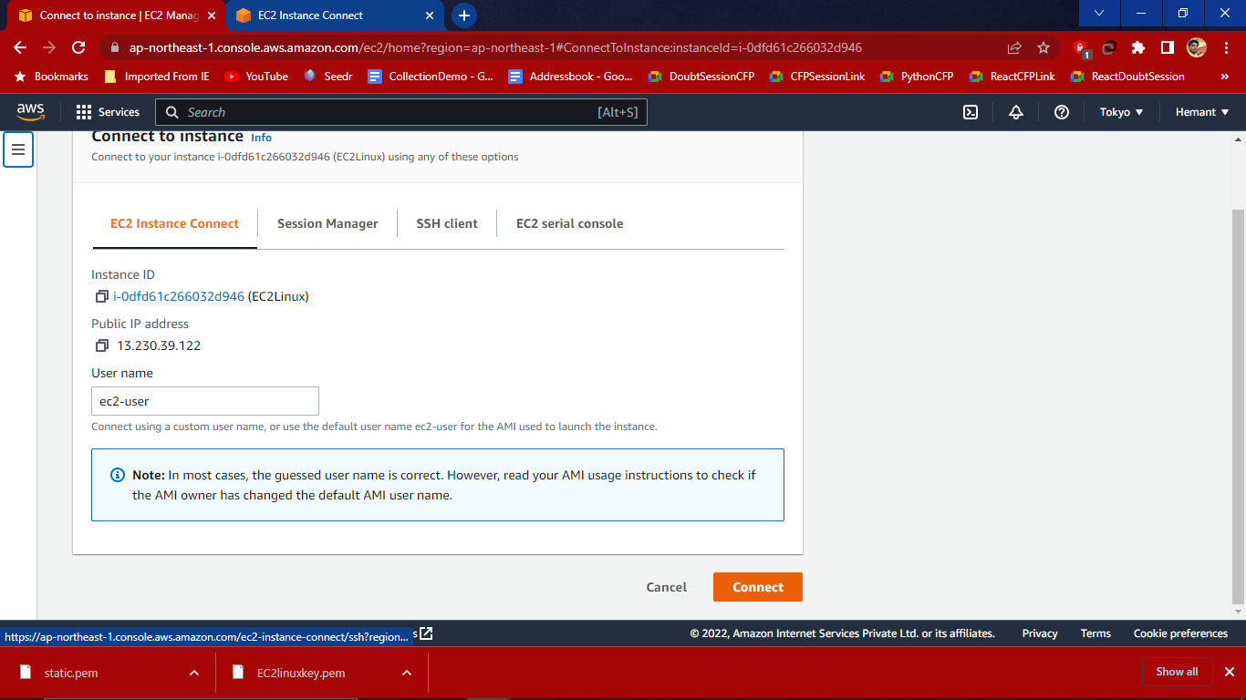
5. After clicking on connect console page open in new tab where we have to use commands to install httpd packages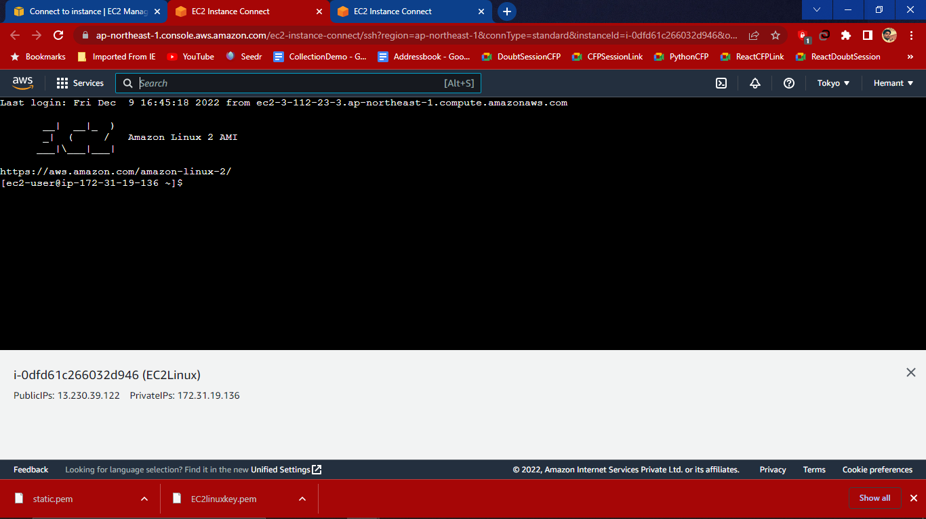
6. Write following commands to install package
7. **sudo su -** switch to the root directory
8. **yum update**- if there is any update available then it’ll update

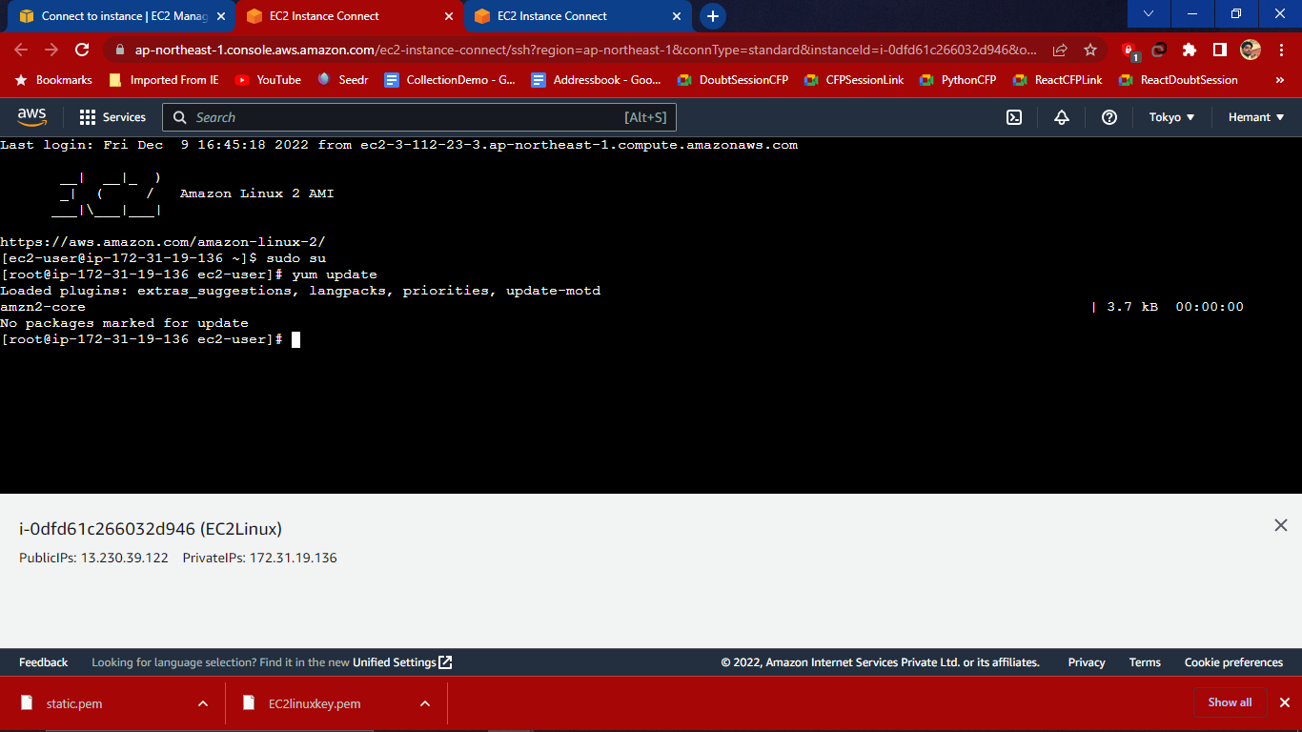

1. **yum install httpd -y** - use this command to install the package

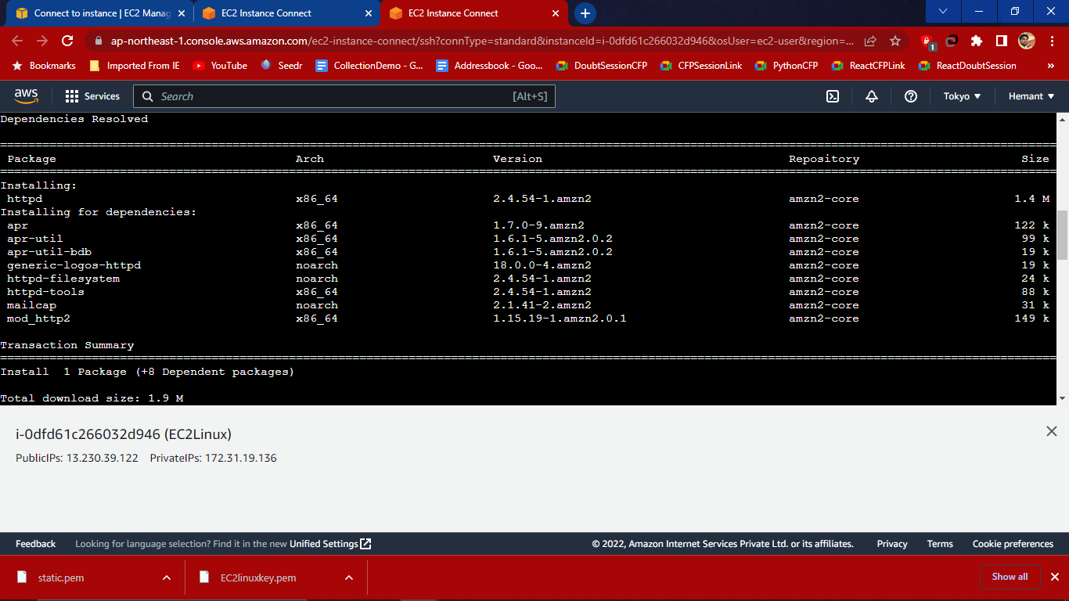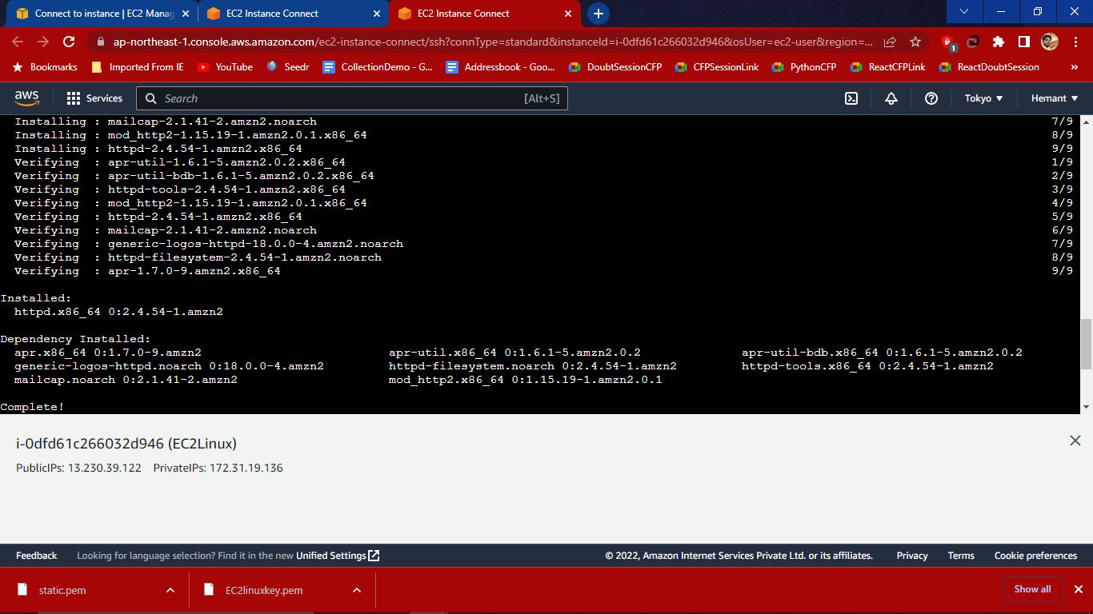

1. **systemctl restart httpd**- Type this command to restart the httpd
2. **cd /var/www/html** - this command is used to move to html
3. **cat > index.html** - to see the html file with [>] angular bracket used to override any text inside the file. Then after clicking enter we have to write anything- This is my first static page of linux operating **system[root[root@ip-172-31-19-136 html]#**

**systemctl restart httpd**

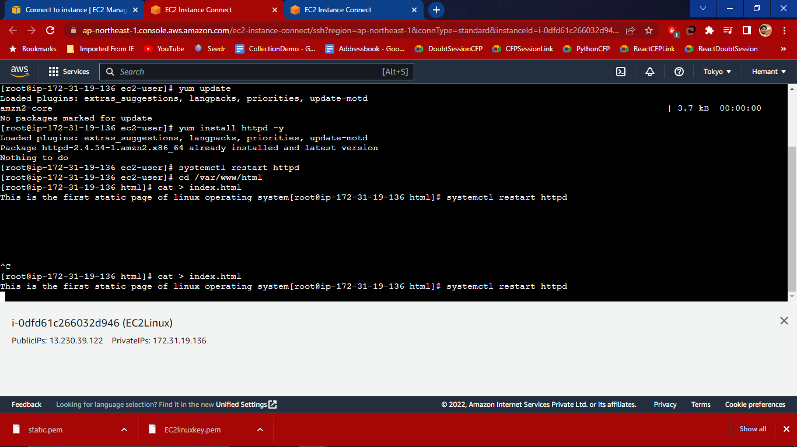

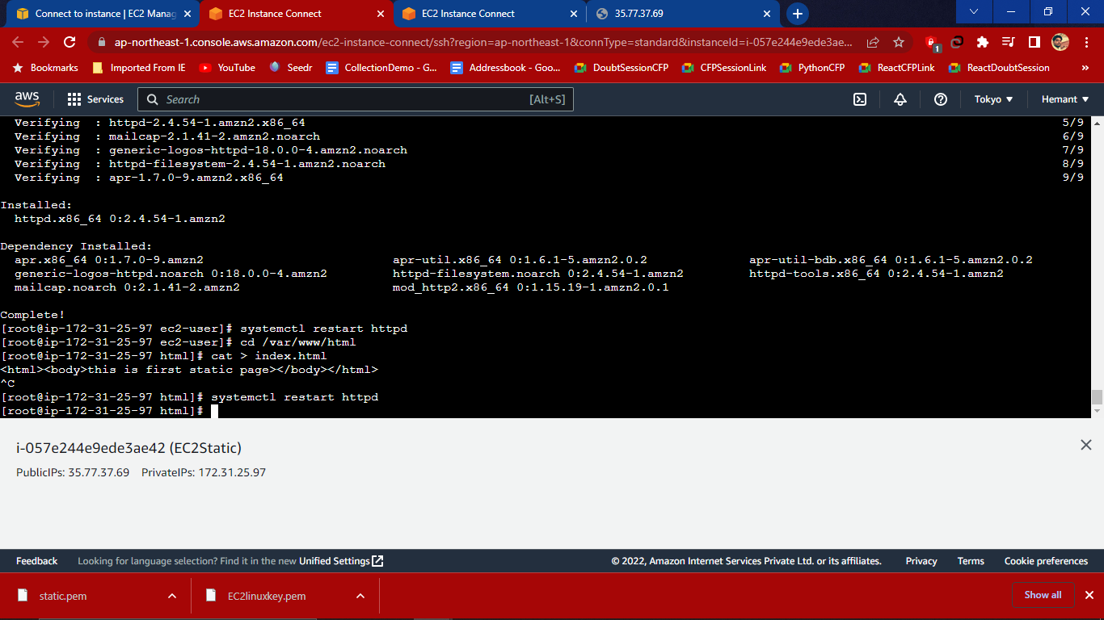

Once it restarts, copy the ip address and paste in web to get the page in web browser if everything goes well page will show with content.

